Q1. Mashroom ke gud dharm quality properity

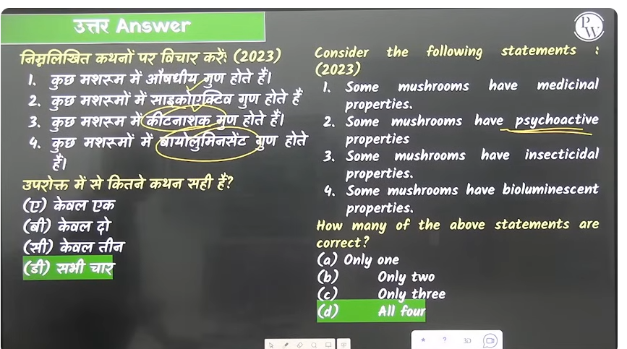

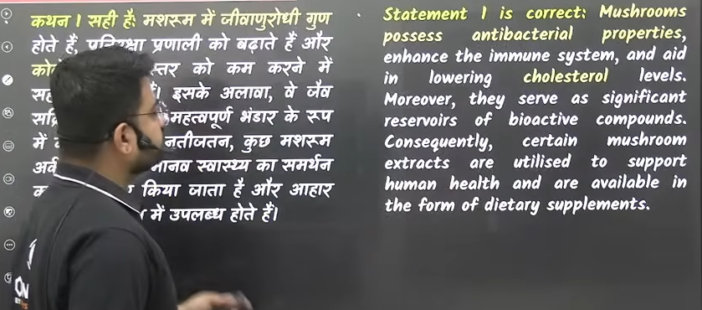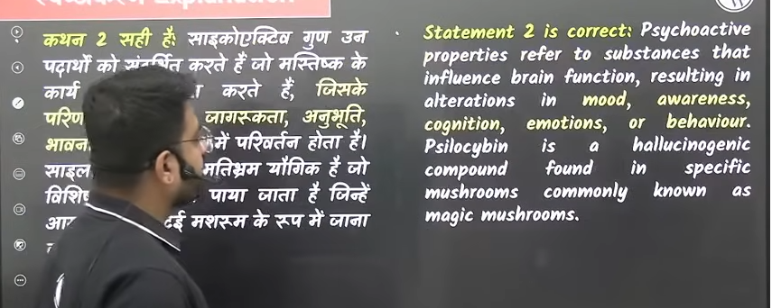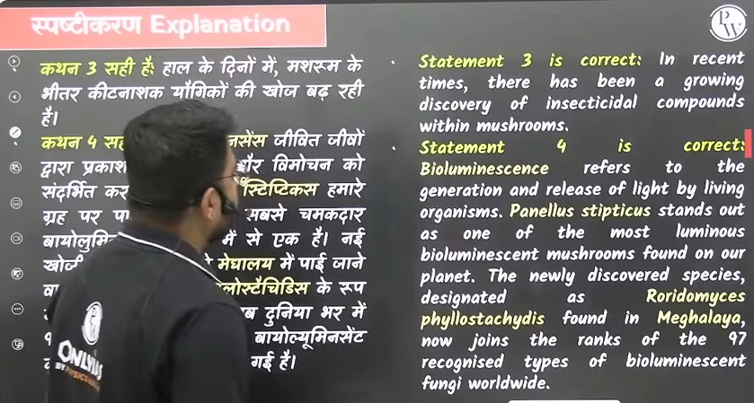

Q. 2 nitrogen fixation

Alfalfa- ye ek grass hote hai jo prakrate me ya hawa me jo nitrogen hote hai usko anya nitrogen ke anya ugeko me convert kanre ka kaam krte hai

Chan ya jitne bhe daal hote hai they are rich in the protien and nitrogen

Nitorgen fixtion- hawa me jo nitrogen hai usko hum anya yogiko me parevartet karne ke chesta kare

/ hawa me jo advik nitrojeng hote hai usko rasayaniek prakryia ke dwara apne yogiko y compund me conver kr de cheical reaction ko induce krna

Matar daale , legumi ,beans, nitrogen fixation

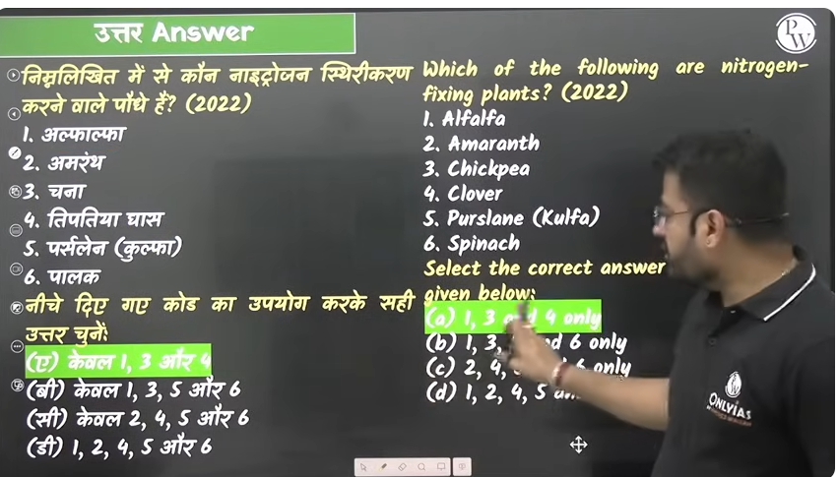

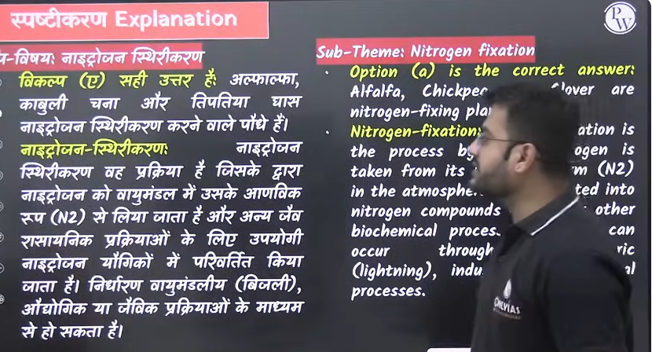

Q. 3 Ecosystem

Jitne bhe jeev and unke as pass ka vatavarn ko milkar ek ecosystem k nirman hota hia

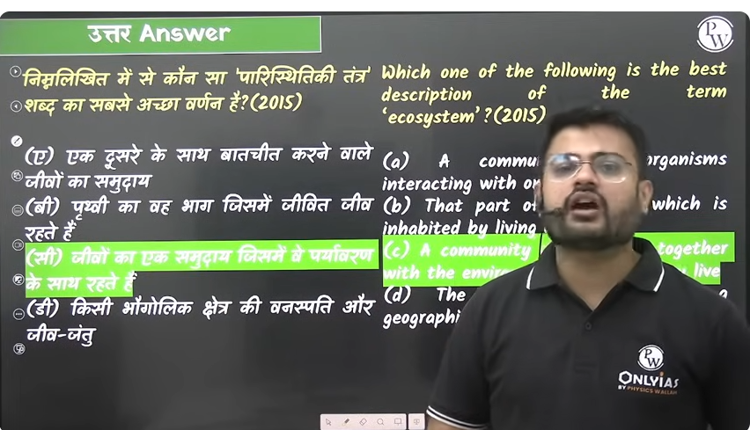

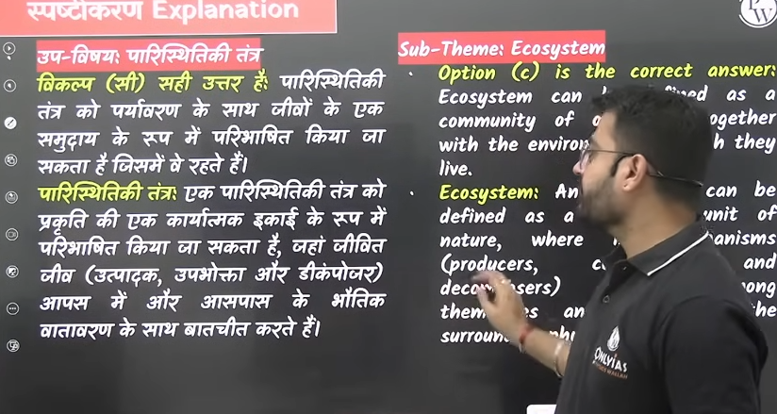

Q. 4. 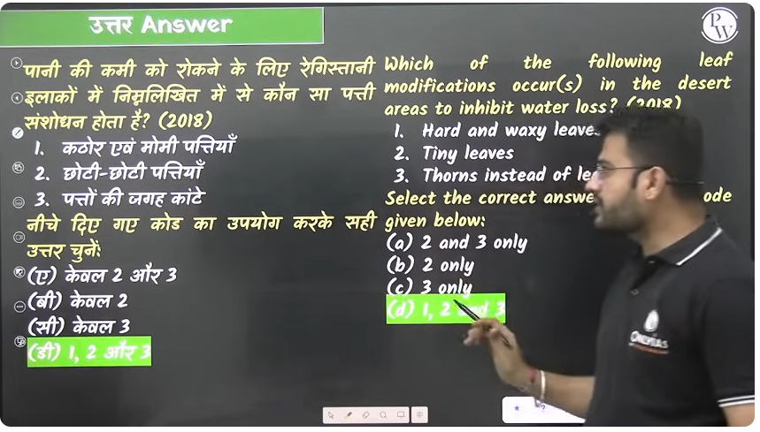

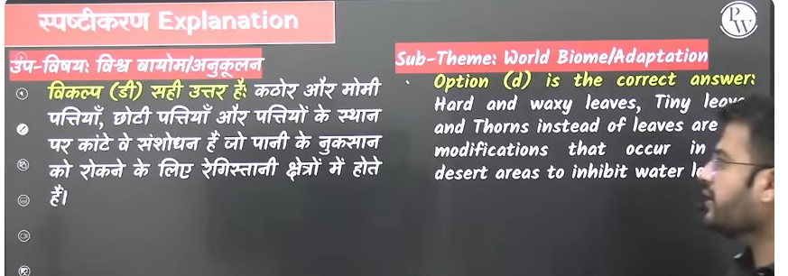



Q. 4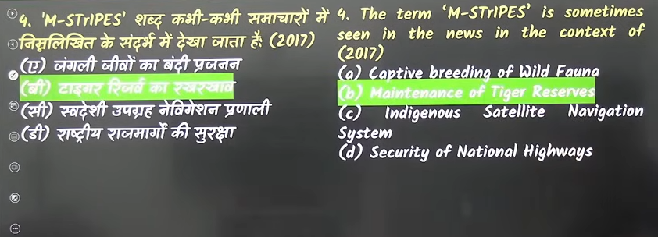

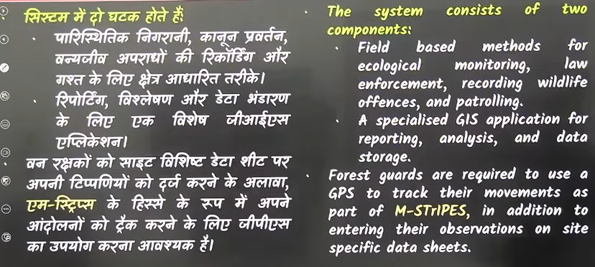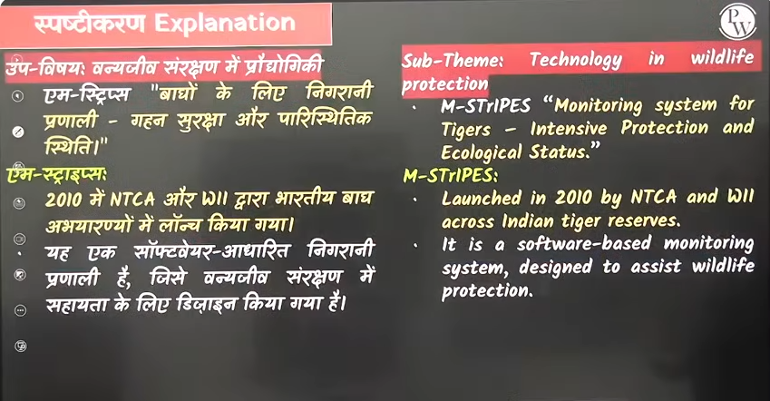

Q.5 pioneer species liken and moss ko hum pioneer species ke naam se bhe jante hai

Lichens = agar mrada hai bhe nahi pathreele jameen hai to sabse pahle ye dono develop honge wahah per inko sirf surface chaye ugen k lyie like kahe per ghar per dewar per chatoano perr plastic per ye har jagha ug jate hai jo metal hai loha hai pladtic hai user bhe lichen develop ho jatte ahi

q. agar bina mitti ke bhe koi chez jjeevet rah rahe hai to wo hai licen and moss means shurat me kise pathrele banjar bhumi me jaha ecosystem abhe develop he nahi hua hai wahah sabse pahle kya tha to answer hai pioneer specises

Moss==iko bhe mittiki awashtka nahi hote hai ye kahe bhe climb kr jate hai kahe per bhe chaayadar area hai wahah ye develop ho jayenge

Pioneeres species- jb kuch bhe nahi hai to kya ug jayega wahah to answer hai lichen and moss ugega wahah per pioner species ugege

Aur jaisejaise wahah epr humus aur soil content acha hoga to uske upar farn chote plant bade plants ugenge aur dhere dhere wo area ecological succesion aur transition me age badega

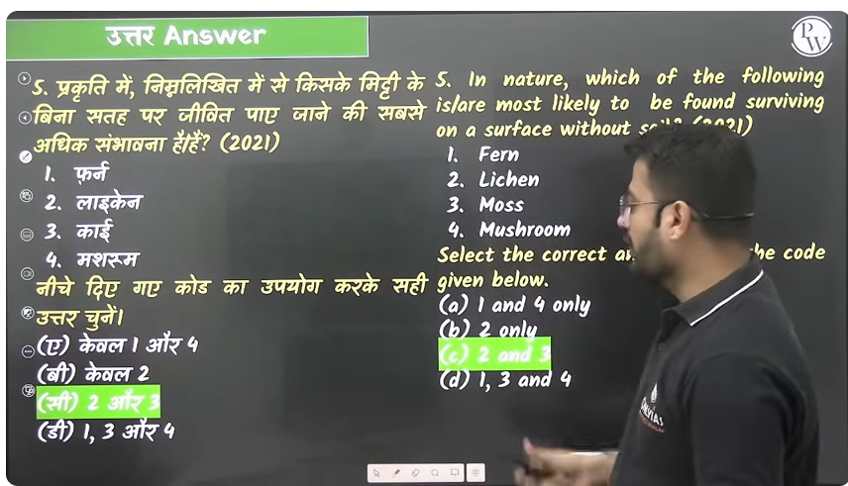

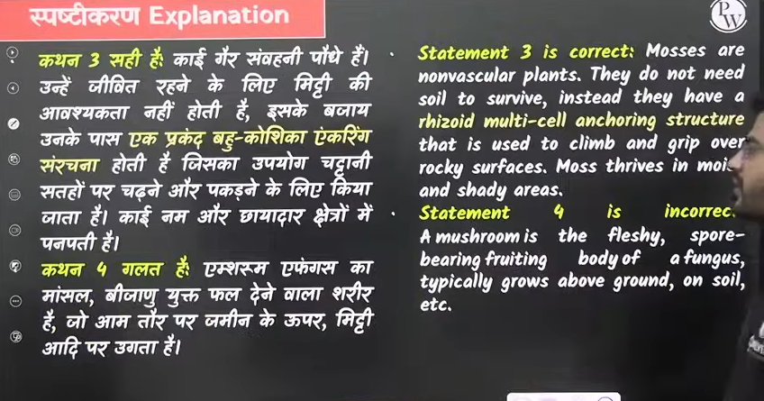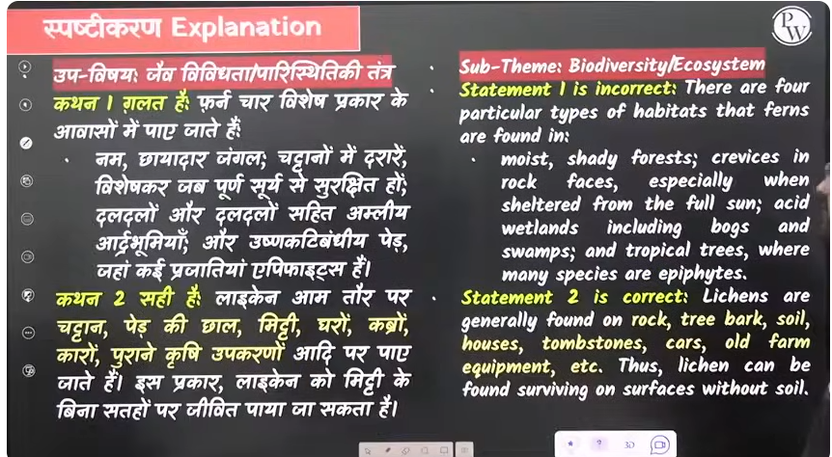

Q. 6

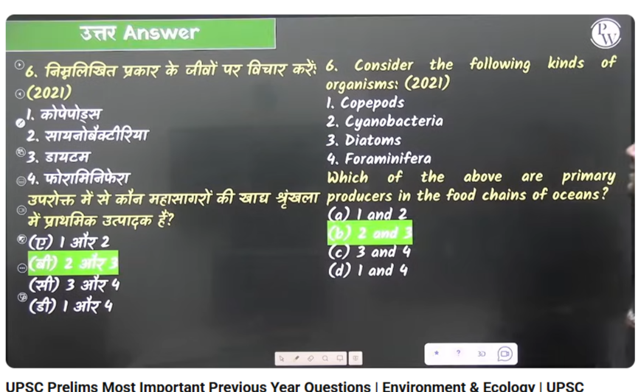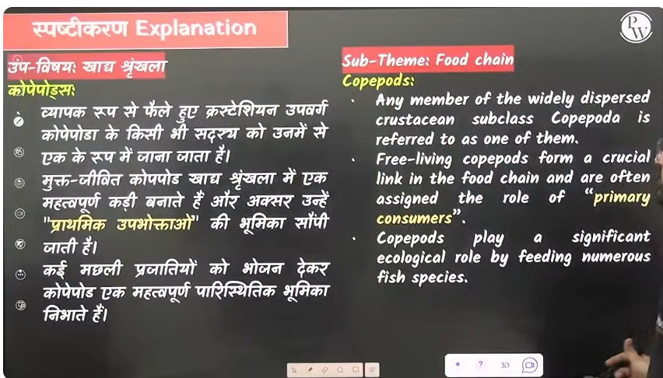

Prathimk upbhokta jo apna bhojankhud banan skte hai . aur mahasagar me apna bhojan khud kaun bana skte h jaise dytam cynobacterial etc.

Q. 7 detritivores (apghatak)?- decompose ka work krete hi – paretantr ke antargat sabhe prakkar ke dead matter hai unko decompose karna .

Jo mrtat jeevo se apna bhojan prapt kre jinko apghatak bhe kaha jata hai ahi

Earthworms- mitti me rahte hai kaam he inka hai humous content banan hai jo mrat jaevek padarth hai unko apghatet karna hai

Seahorse- secondary or primary may be

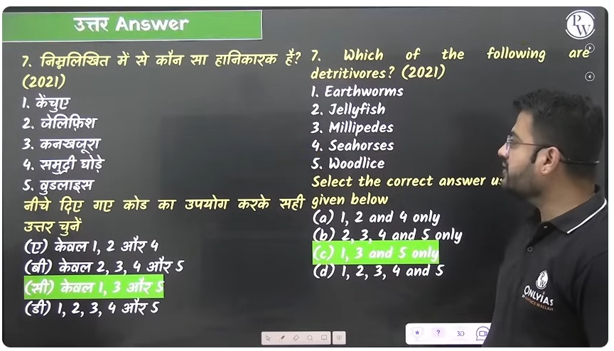

Q. 8 chattano ke apchya –

Chattano ke jo mineralas like phosphate and other hote hai wo dhere dhere leak apchay hote hai jaise jaise chattan ka apchaya hota hia hawa se pani se aur any gatevidhyio se agar un chattano ka weatering ho rahah hai to dhere dhere jo phasphete ayan aor other minerals hai wo break hokar jaiv bhu rasaynik chakr ya phosphyet cycle me dhere dher enter krte hi

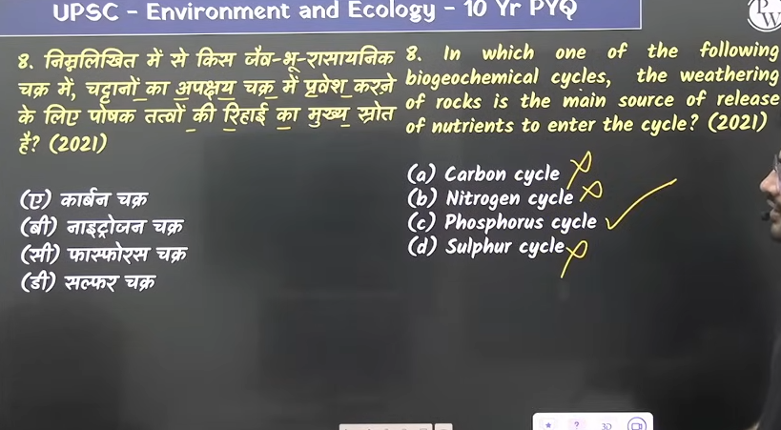

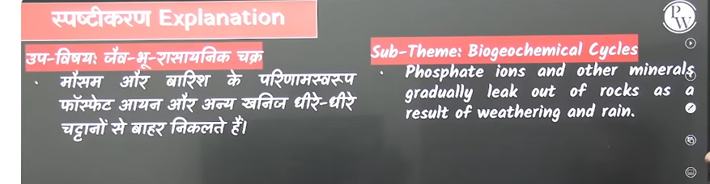

Q. 9 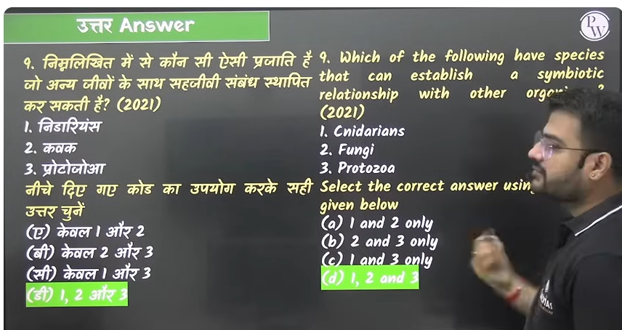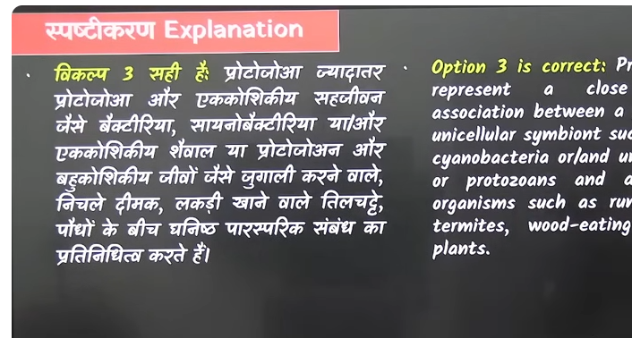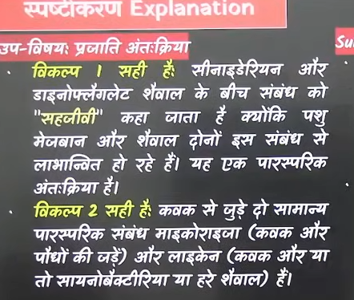

Q. 10

Approximately **97.5% of Earth's water is salt water**, found mostly in oceans. The remaining 2.5% is freshwater, but almost 69% of this is locked in glaciers and ice caps, with even smaller amounts accessible as groundwater, lakes, and rivers.

* **Salt water**: Makes up the vast majority of the planet's water, primarily in oceans, seas, and saline lakes.
* **Freshwater**: Only a small fraction of total water is freshwater, with much of it stored in ice caps and glaciers or as groundwater.
* **Accessible freshwater**: The amount of freshwater readily available for human use in rivers, lakes, and the atmosphere is very small

पृथ्वी की सतह का लगभग **71% हिस्सा पानी** से और **29% हिस्सा जमीन** से ढका हुआ है। पृथ्वी पर मौजूद कुल पानी का लगभग **97% खारा पानी** (महासागरों में) है और केवल **3% मीठा पानी** है। मीठे पानी का भी अधिकांश हिस्सा ग्लेशियरों और बर्फ की चोटियों के रूप में है, जबकि पीने योग्य पानी बहुत कम है।

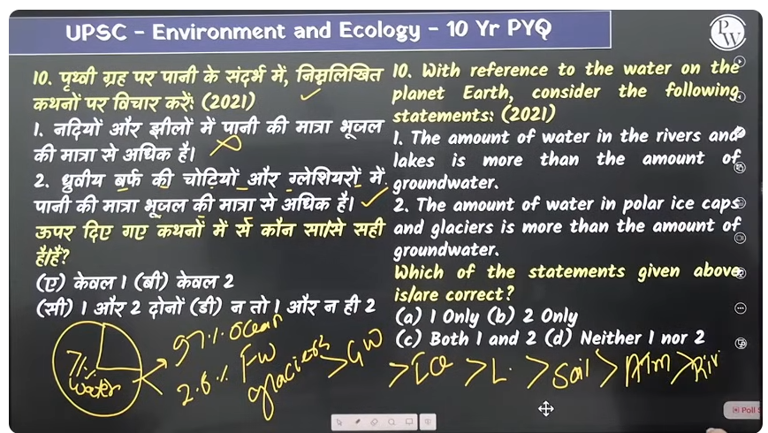

Please read this question in English

**पानी और ज़मीन का अनुपात**

* **पानी:** लगभग 71%
* **ज़मीन:** लगभग 29%

**पानी का प्रकार**

* **Salt water**: About 97% to 97.5% of the Earth's water is saline (salty).
* **Fresh water**: The remaining 2.5% to 3% is fresh water.
  + इसमें से अधिकांश हिस्सा ग्लेशियरों और बर्फ की चोटियों के रूप में है।
  + नदियों, झीलों और भूमिगत जल के रूप में उपलब्ध पीने योग्य मीठे पानी की मात्रा और भी कम है।
* **Distribution of fresh water**: Most of the fresh water is not readily accessible, with about 68% in ice caps and glaciers, and around 30% as groundwater.

पृथ्वी पर मौजूद कुल पानी का लगभग 3% ही मीठा पानी है, जिसमें से केवल 0.3% से 1.2% हिस्सा ही सीधे पीने योग्य है। यह पीने योग्य पानी नदियों, झीलों और भूजल में पाया जाता है, जबकि बाकी पानी ग्लेशियरों, बर्फ और जमीन के बहुत नीचे जमा है।

* **कुल मीठा पानी:**

पृथ्वी पर कुल पानी का केवल लगभग 3% मीठा पानी है।

* **सीधे पीने योग्य पानी:**

इस 3% में से भी, केवल लगभग 0.3% से 1.2% हिस्सा ही नदियों, झीलों और आसानी से पहुँच योग्य भूजल के रूप में उपलब्ध है।

* **जमा हुआ पानी:**

बाकी बचा हुआ मीठा पानी मुख्य रूप से ग्लेशियरों, बर्फ की चोटियों और पर्माफ्रॉस्ट (स्थायी रूप से जमी हुई जमीन) में जमा है।

* **खारा पानी:**

पृथ्वी पर कुल पानी का 97% हिस्सा खारा (नमकीन) है, जो समुद्रों में है और पीने या खेती के लिए उपयुक्त नहीं है।

71%- water 29% land

71%- 97% salt water 3% freshwater

2,5% - glaciers, > then bhumigat jaal ground water> ice> lakes >soil moisture> atmoshper moist> river

**कुल जल:** पृथ्वी के कुल पानी का लगभग **2.5%** ही ताज़ा पानी है, जिसमें से अधिकांश हिस्सा बर्फ के रूप में है।

* **Salt water**: About 97% to 97.5% of the Earth's water is saline (salty).
* **Fresh water**: The remaining 2.5% to 3% is fresh water.

Only about 2.5% of the water on Earth is freshwater. The vast majority of this freshwater is frozen in ice caps and glaciers (about 68.7%) or is underground as groundwater (about 30.1%), with only a tiny fraction (0.3%) existing in rivers, lakes, and the atmosphere where it is more accessible to life.

* **Total freshwater:** 2.5% of all water on Earth
* **Ice and glaciers:** About 68.7% of all freshwater is locked in ice, such as glaciers and polar ice caps.
* **Groundwater:** About 30.1% of all freshwater is underground.
* **Surface and atmospheric water:** Less than 1% of all freshwater is in lakes, rivers, swamps, and the atmosphere.
* **Accessible surface water:** Of the freshwater that is not frozen or underground, a significant portion is in freshwater lakes, with a much smaller amount in rivers and the atmosphere.

Nadyio k pani to soil moisture and atmosphere moisture se bhe kaam hota hai

ग्लेशियर (हिमनद) बर्फ का एक बहुत बड़ा और स्थायी पिंड होता है, जो समय के साथ जमा हुई बर्फ से बनता है और अपने ही भार के कारण धीरे-धीरे जमीन पर बहता रहता है। ये मुख्य रूप से ठंडे, पर्वतीय या ध्रुवीय क्षेत्रों में पाए जाते हैं।

An icecap is a large, permanent mass of ice and snow that permanently covers a large area of land, often forming a dome shape. They are typically found in polar regions or on high-altitude mountain peaks and are a type of glacier that slowly flows downhill under its own weight.

Difference beween ice cap nad glacier

An ice cap is a dome-shaped mass of ice covering less than 50,000 square kilometers (20,000 sq mi) and spreading outward. A glacier is a large mass of ice that flows downhill under its own weight, often confined by the surrounding topography. Think of an ice cap as a "parent" mass that can feed several glaciers flowing from its edges.

|  |  |  |
| --- | --- | --- |
| **Feature** | **Ice Cap** | **Glacier** |
| Shape and flow | Dome-shaped, flows outward from the center. | Varies, but typically flows downhill, often confined by valleys. |
| Size | Less than 50,000 km². | Varies widely, but often larger than ice caps, although ice caps are a type of glacier. |
| Topography | Largely unconstrained by underlying terrain. | Often follows and is shaped by the terrain, such as valleys. |
| Examples | Vatnajökull in Iceland; Severny Island in Russia. | Alpine glaciers in mountain valleys; outlet glaciers flowing from an ice cap. |

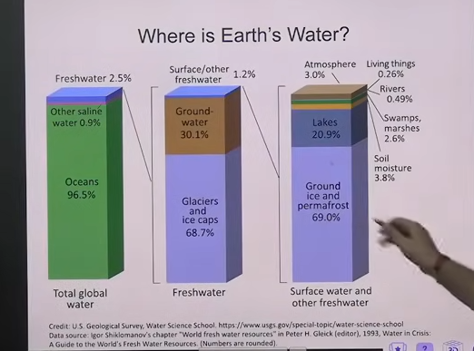

Q. thermophyile bacterial, psychrophile bacterial Acidofile bacterial

Ph below 4 is acidic = Acidic- Acidofile bacterial

6.5 se 7 is ph ke beech surviv kr jata hai koi bhe bacteria because this ph is good for bacterial growth

Ph above 7 is = chareeya 7 upakr alkline environment banta hai jisko hum chareeya kahte hai jaise yaha per jaise yeast hai kavak grow krte hai = these bacterial is call Allcilophiles

To extreme condition me bhe grow karne wale bacteria humko dekkhne ko milte hai

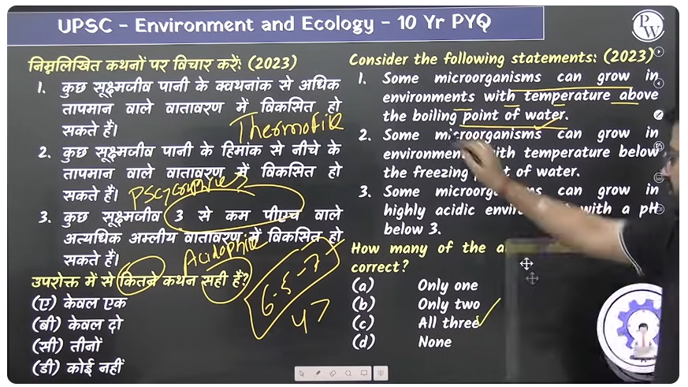

Here Answer is All correct

Q. 12

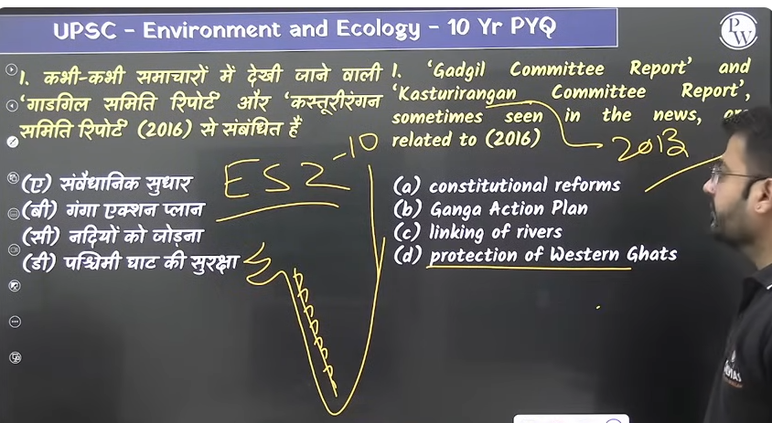

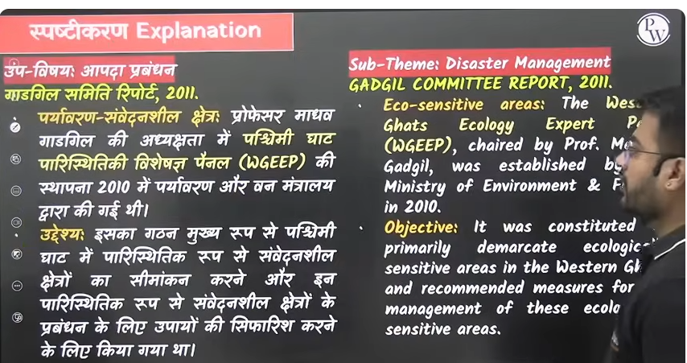

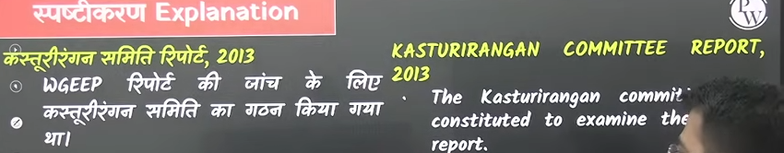

Q. 13 titliya ek phool se dusre phool per jate hai aur ye paraggan ka kaam karte hai

Anek species like west titatyia jaur bhe hai jo depend hai titli per titli unka bhojan hai titli ke jansankya me kami se anya species me bhe kame aa jayege

Ye khyadya shrankhla me jude hue hai ek dusre k upar nirbhar hai

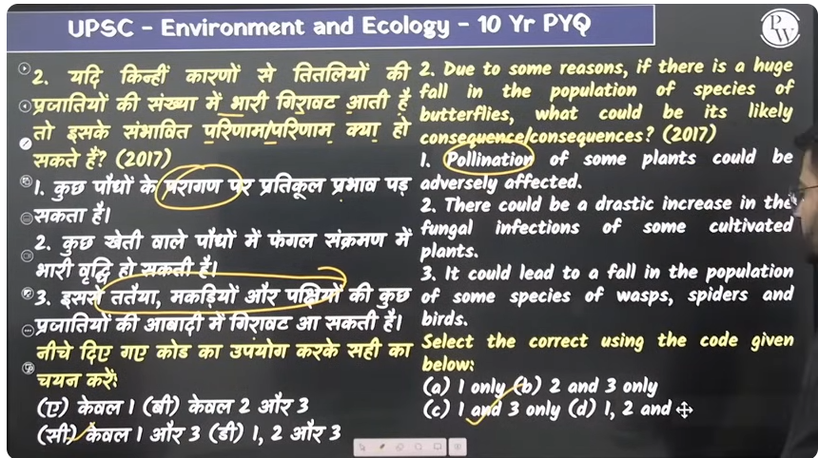

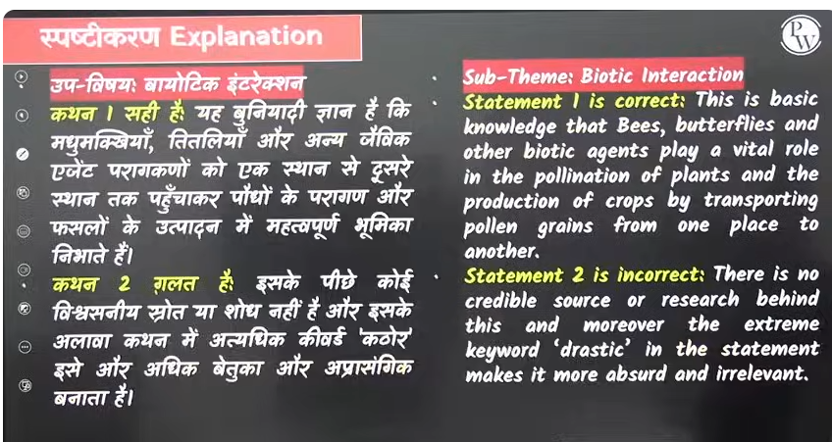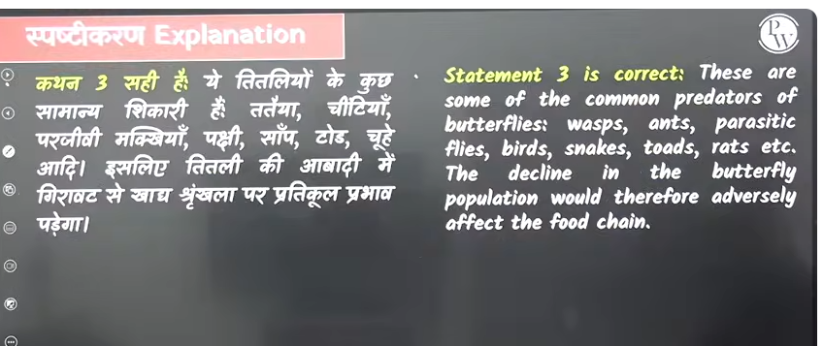

Q. 14 prakrit machar bhagane keg has prakritik machar nirodhak hai

Jo tropic aur subtropical region hai wahah ye tropical ghass ke rop me ugae jate hai china and bharat me isska utpadan Jayda hota hia

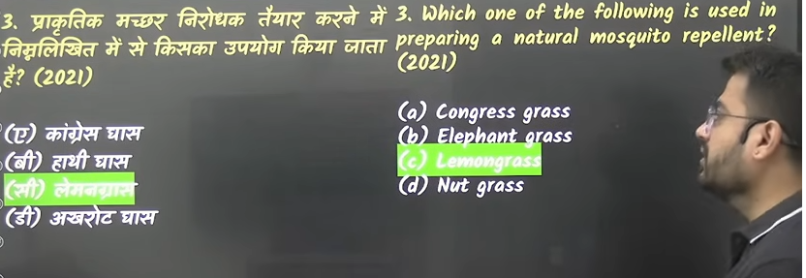

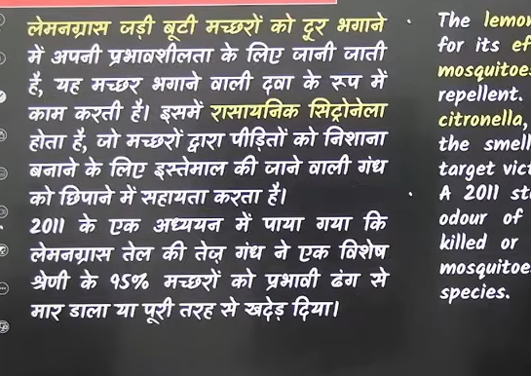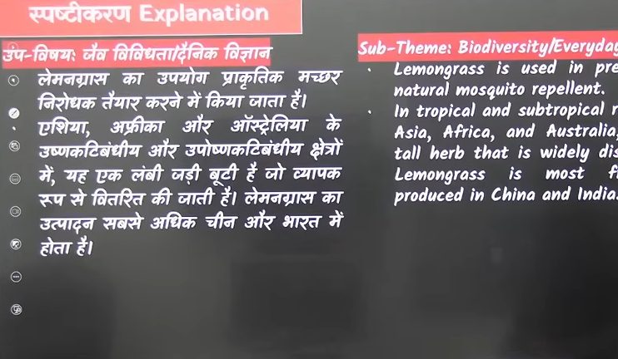

Q. 15 Savana Ghass maidan

Kaun sa mahadeevp hai jaha ek bhe ghaas ke maidan nahi hai – Dakshin dhru per adhari antartica mahadeevp barf se achadeet hai ice covered hai waha koi bhe ghas ke maidan nahi hai

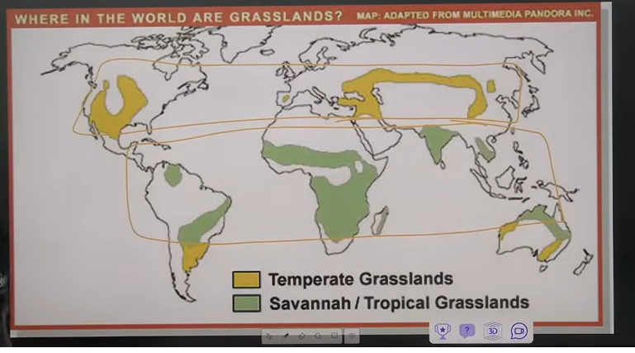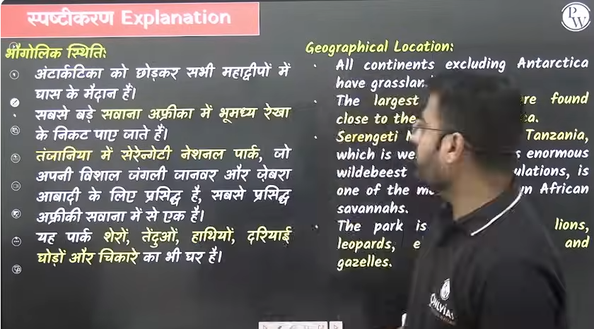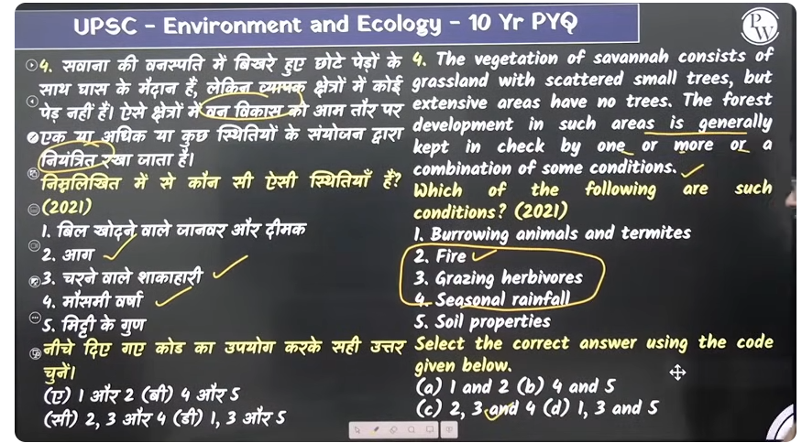

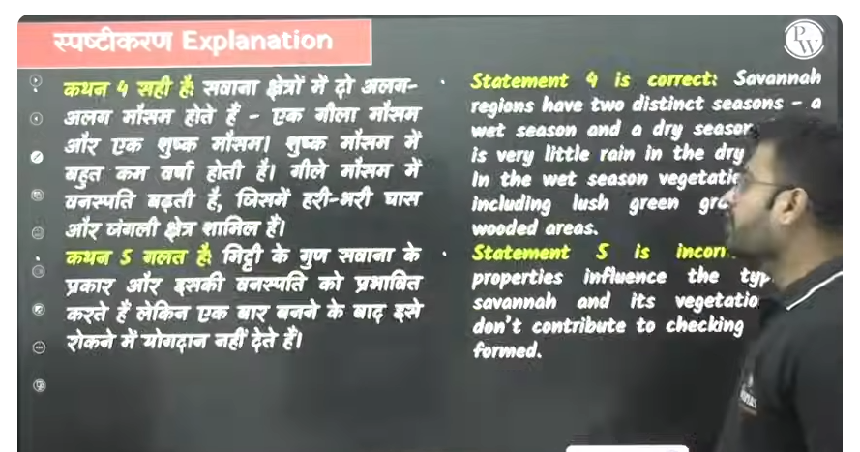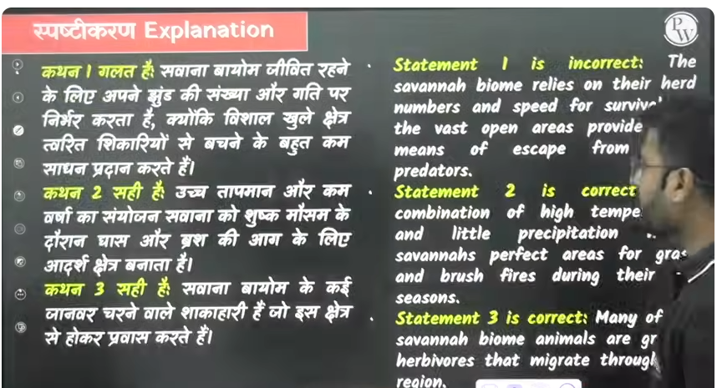

Q. 16 khet jo hai wo manavjanit paritantr hai ye prakratik paretantr nahi hota hai khet natural biom nhi hi khet kratrim paretantr hota hia

Natrius oxide – N2o

Wetland jo bhe hote hai wo accha source hota hi mmethen production ka

Chawal ke kheto ko jaal se bhara rkaha jata hia

To agar hum Jayda area ke andar rice ko cultivate karenge to us area me to us area me Jayda se jayada anthropogenic n2o co2, ch4 source ka utsarjan dekhne ko milega isley global warming ka ek reason rice farming ko bhe kahah jata hai

Rice farming se green house gas effect badh rahah hai

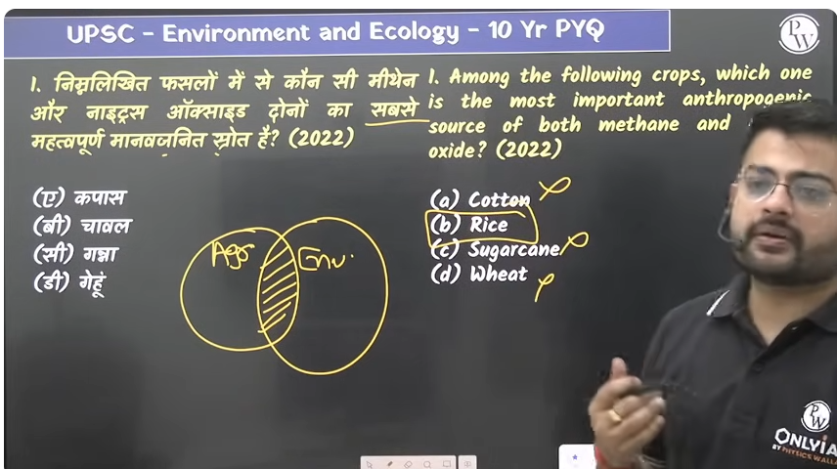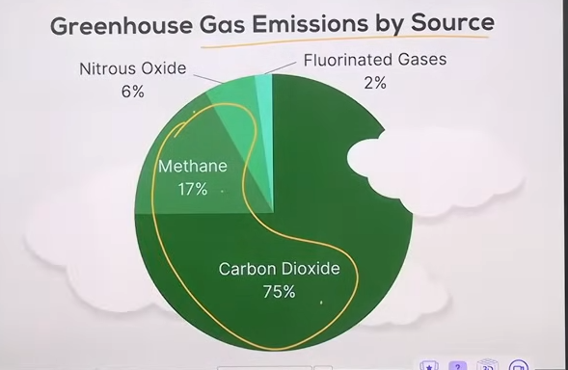

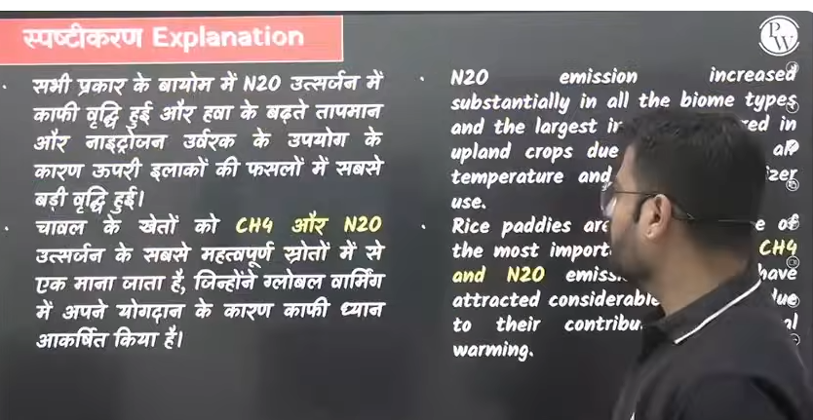

Q. 17 old method of chawal ugane

When chawal ke kheto ko panei Jayda dalogoe to wo adra bhumi rahege wetland rahega Jayda bacterial aur fermentation wale cheze honge jisse methane Jayda utsarjeet hoga

Iske tareekse methane utsarjand jayd hota hai isley second methoda layd gaya chawal ke kheti ka

To isley nae treeke se chawal ugaengge

Ek time k lyei jitna pani chaeye daal dyia fir pani kaam hua aur khet sukha uske kuch time baad ek time ke baad thoda sukhne ke baaad aur pani daal dyia to hum chwal ke kheto ki alternate wetting and drying karenge

Aise karne se kya fayda hoga below are given

All are correct in option

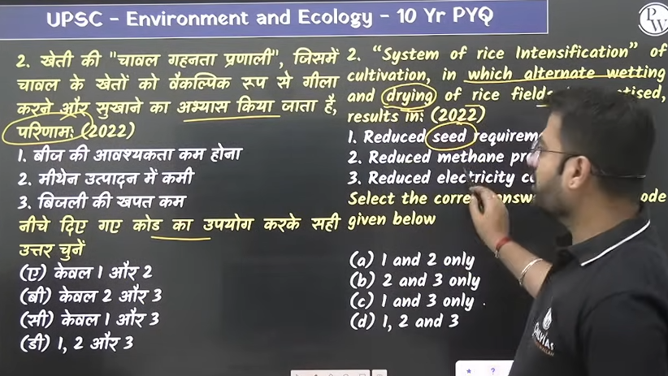

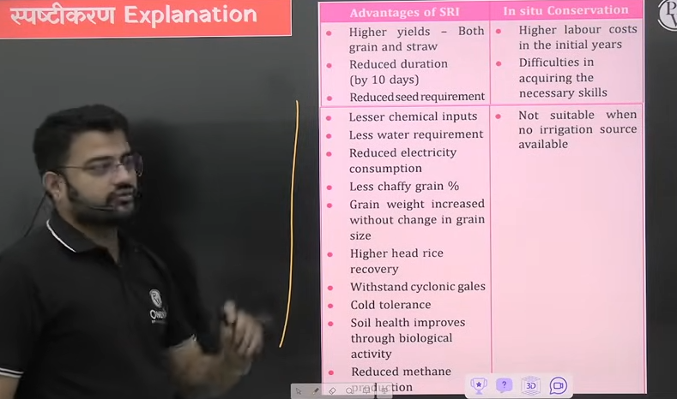

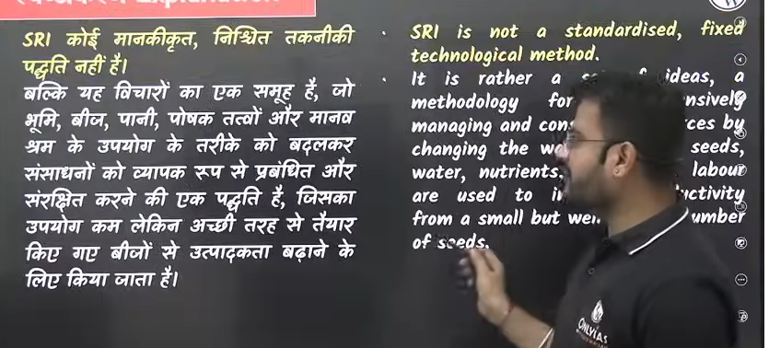

Q . 18

Bhujaal me nitrate ka reesav menas bhumi ka jaal pradushit ho jayega

Mitti me nitrogen ke adhik hone se nitrogen isthrekarna nahi hoga because nitrogen istherakanr me jinte bhe legumes ya bacterial hote hai wo hawa air se nitrojgen lete hai na ki fertilizer se nitrogen lete hi

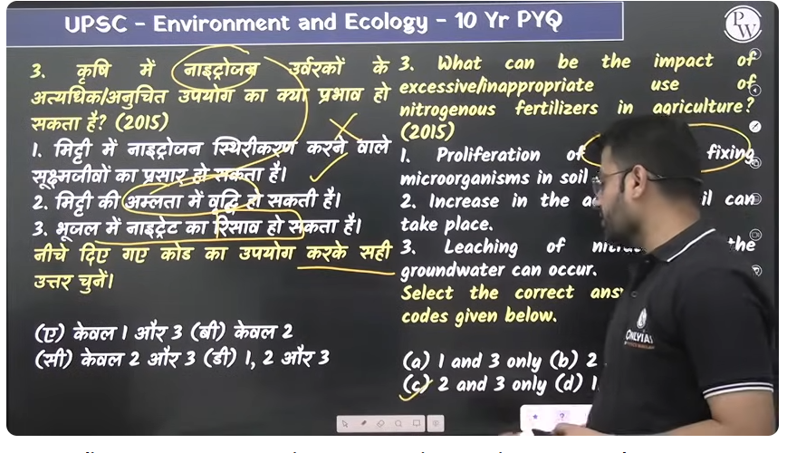

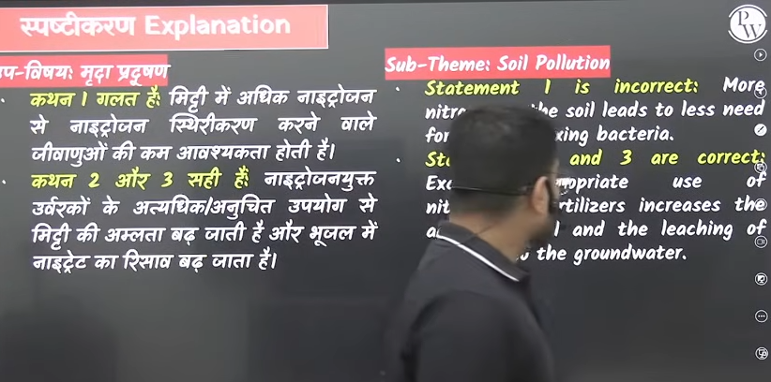

Q 19

Bhumi ki shuny jutae- means jab hum khet ko jote gen ahi to jo khet meneeche moisture hota hai wo maintain raheg jb khet kojottae hai tb jo layer mitti ki neeche se upar ata hai uska moisture vaporu ho jaya hai jisssem mitti sukhe ho jate ahi jisse hum soil moisture ko conserve kr skte hai soil moisture maintain rahe soil moisture uppar naa aye udh na jaye

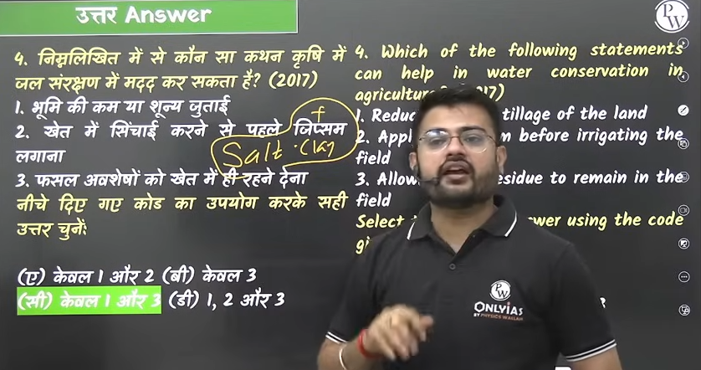

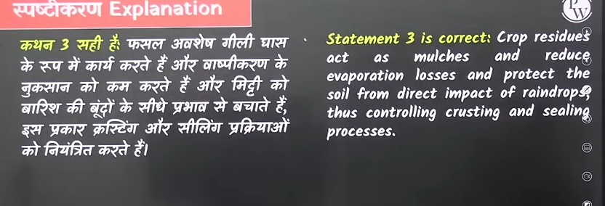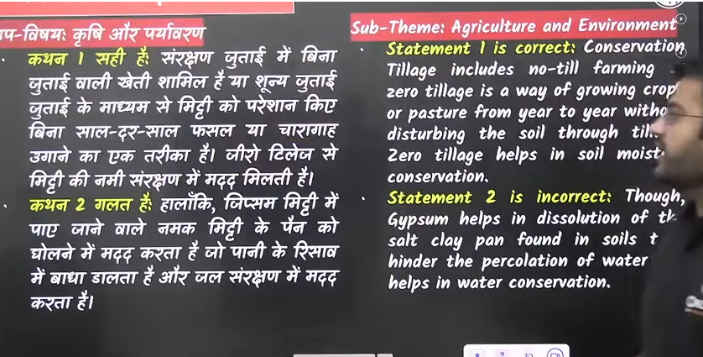

Q. 20 fertilization – means sankhyatm k vradhi

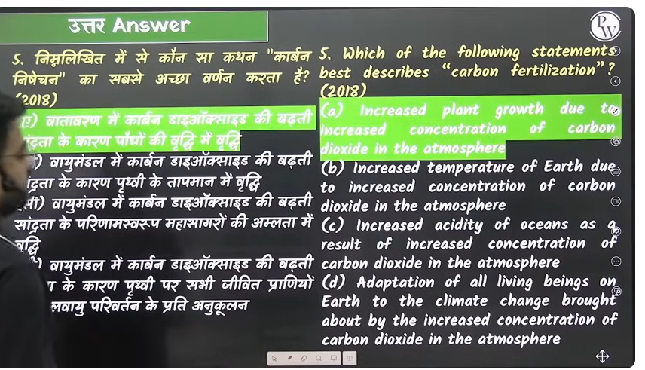

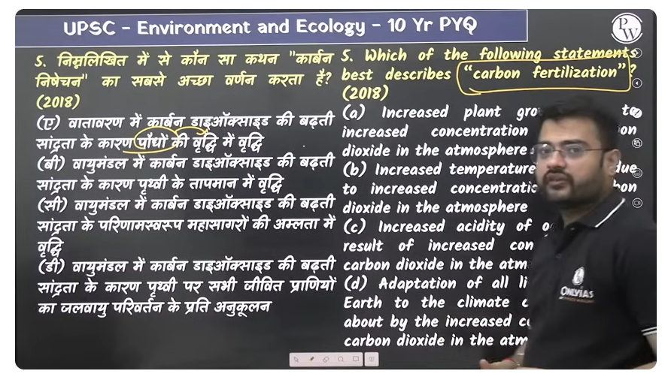

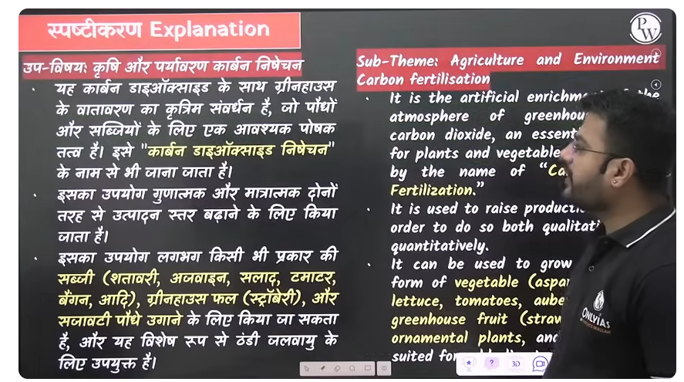

Because ped paudhe co22 ko observe krte hi co2 ped paudho ka bhojya padhrth hia isley

Q21.

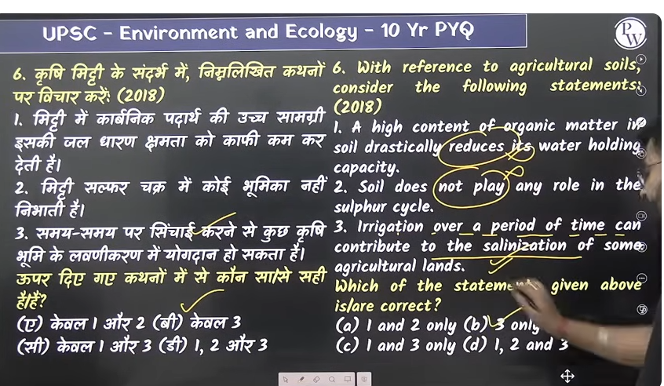

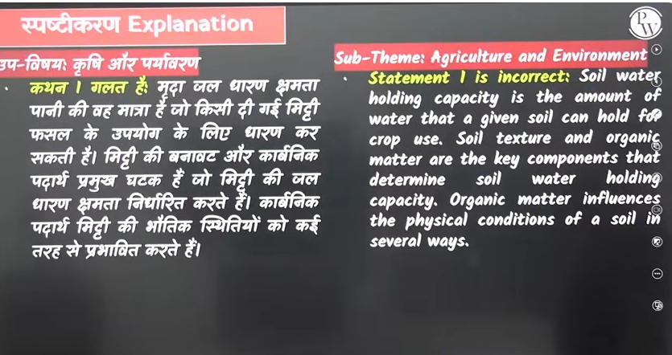

Q. 22 Ans 2, 4, 5

Monoculture - means ek he crop ko bar bar ugan wo us khet k lyie hanikarak hai in place of this use crop sequencing or crop rotation 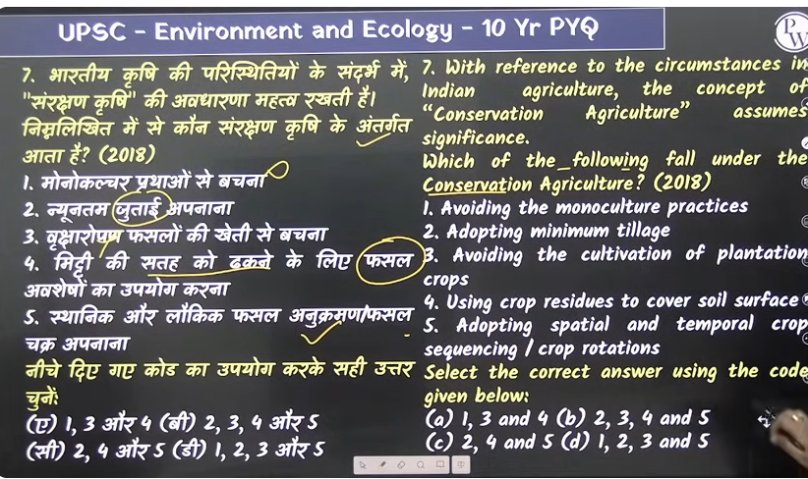

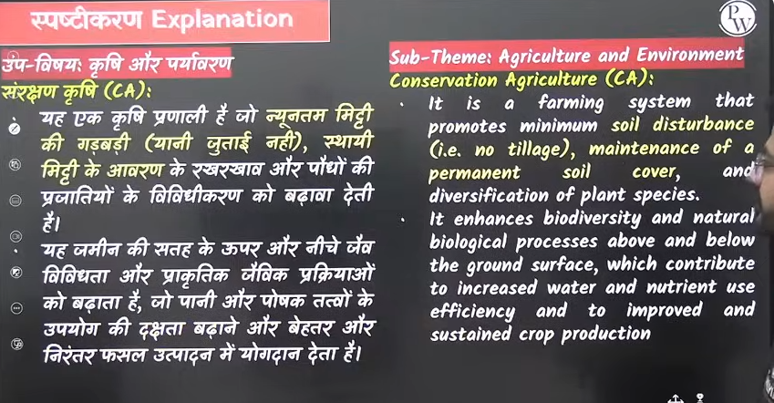

Q. 23 ek hota hai pesticides aur ek hota hai insecticedes

Keetnshk – ye wo rasayan hote hai jo paudho lagne wale bimaryio ko khtm kanre k liu use hot hi ya fir puadho per jo keedha , lage haunko khtma karne k lyie use hota hai

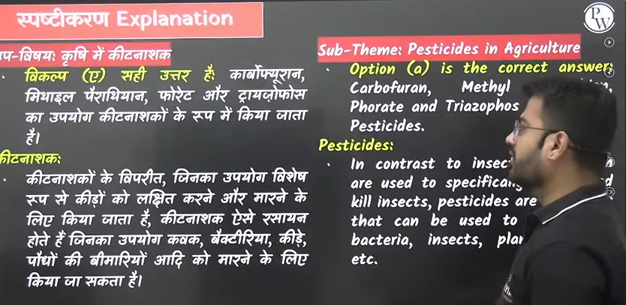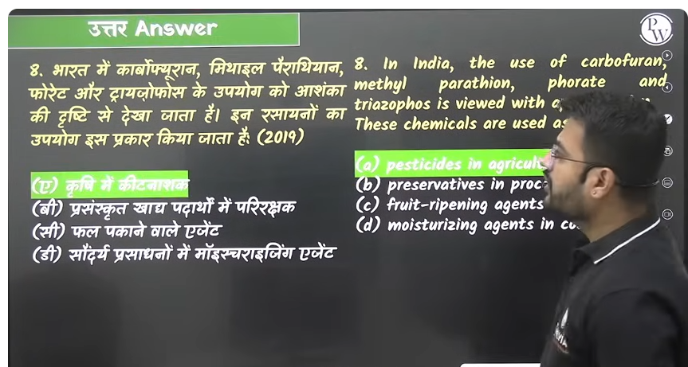

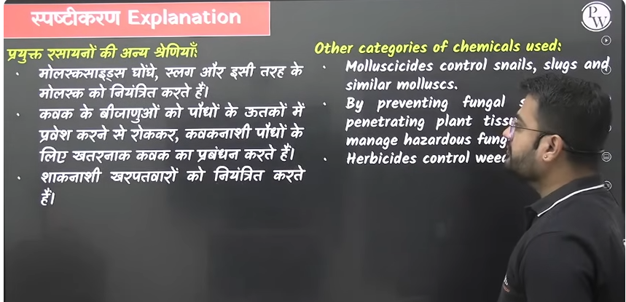

Q24 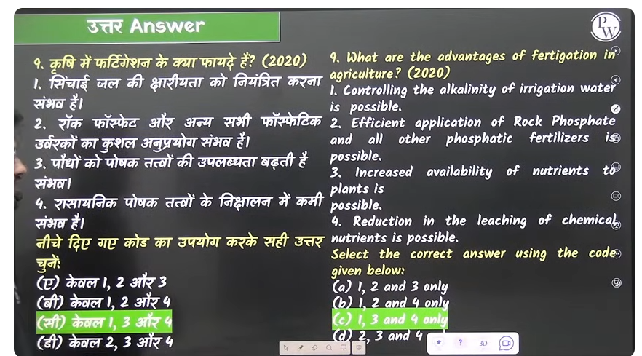

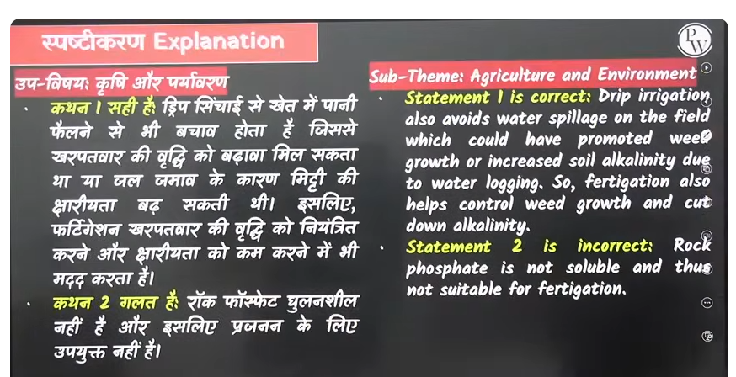

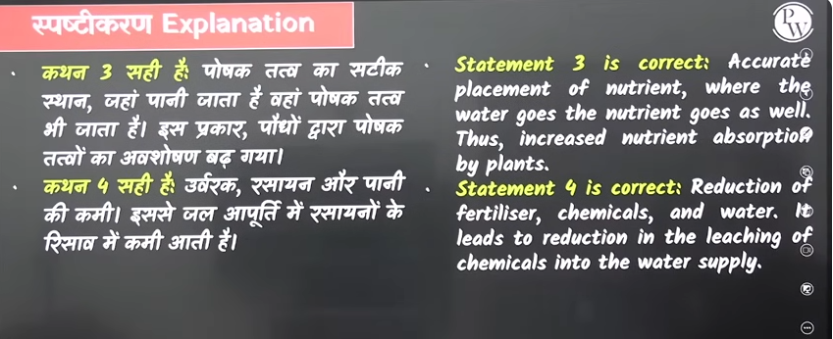

Q. 25

Pedh paudhee bhojan kiss banate hai carbon dioxide Prakash shanshleshadh

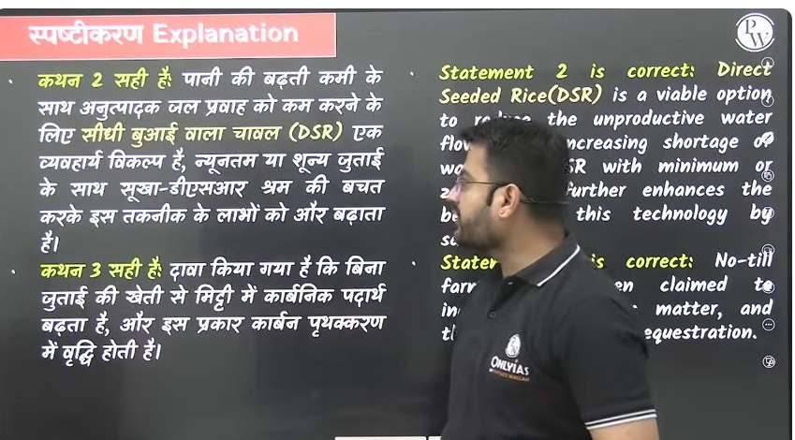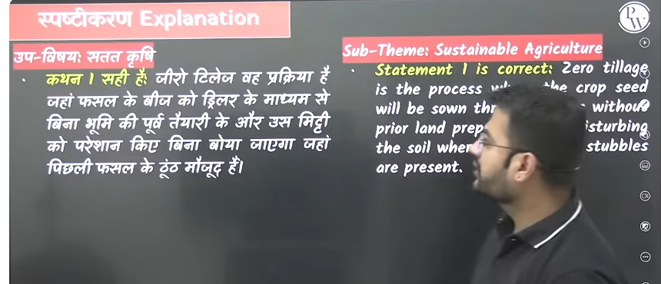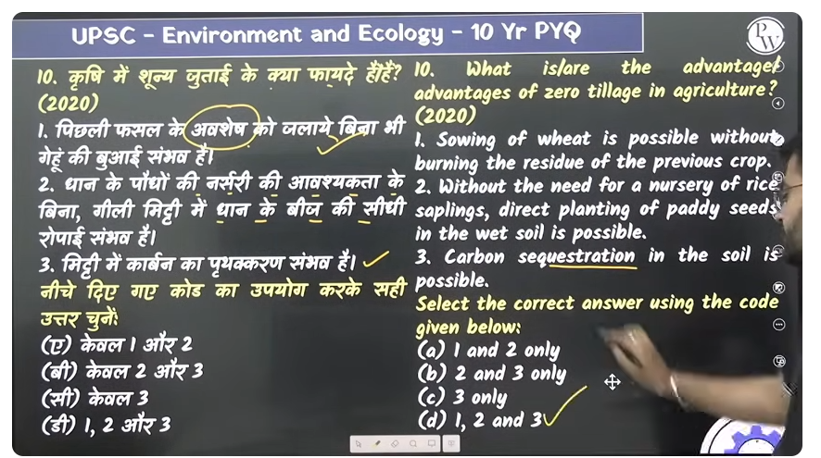

Q. 26 All are correct

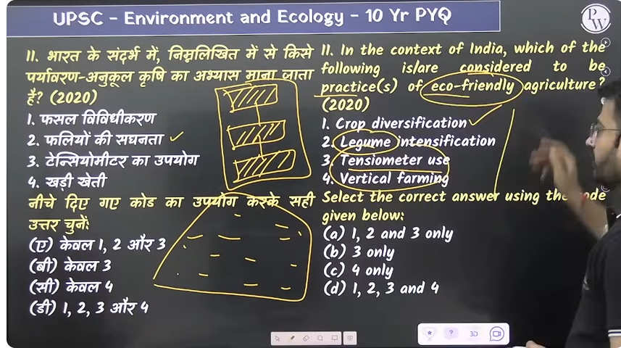

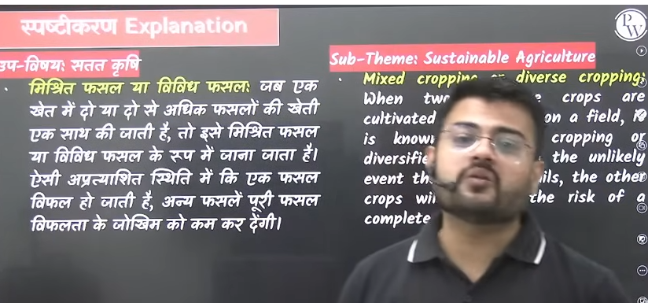

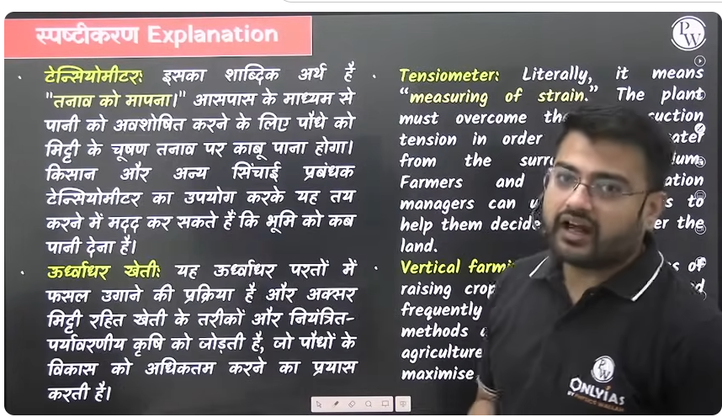

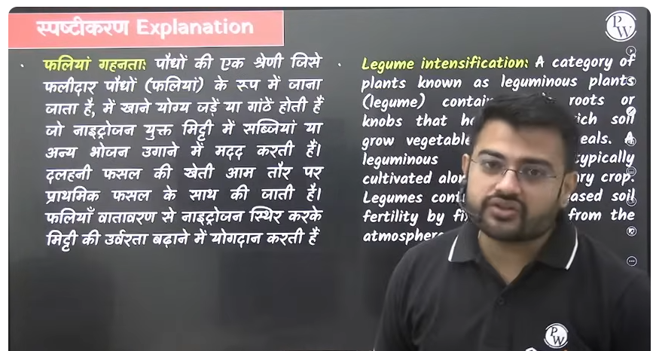

Q. 27

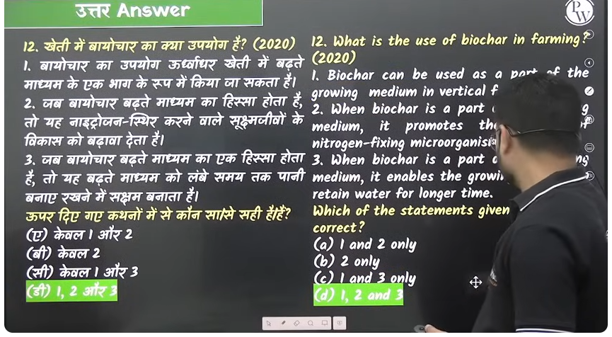

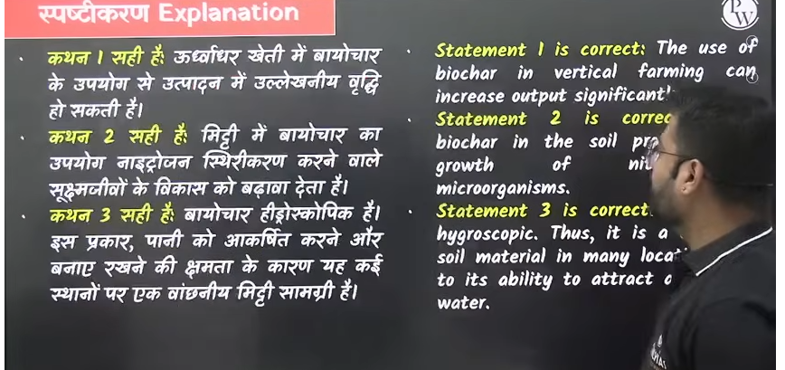

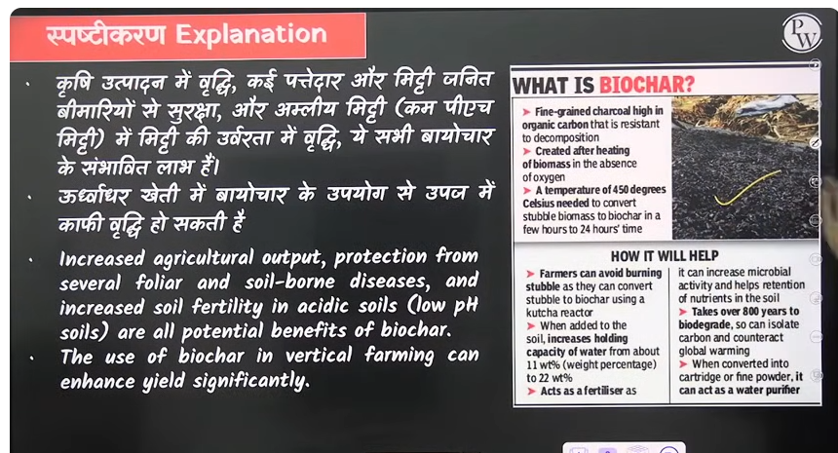

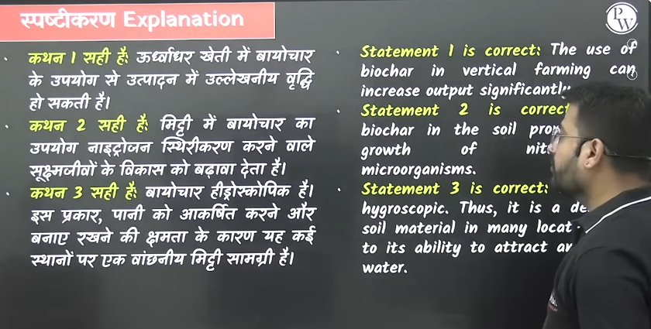

Q28

Mulching- jo hai usme purane parale jaise anya dead material ko beecha do j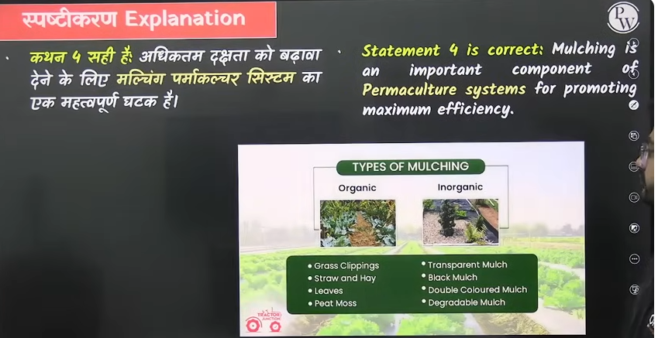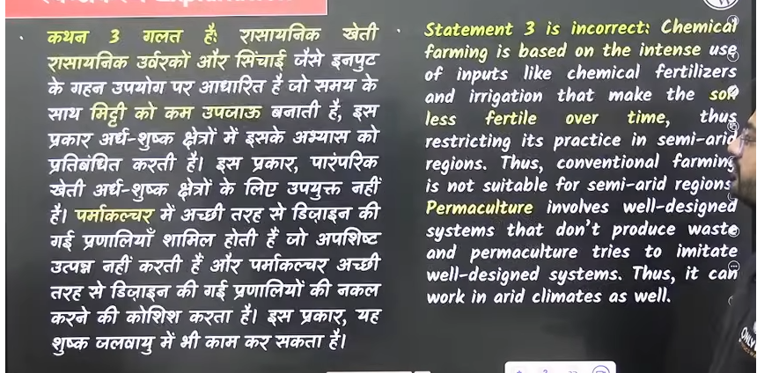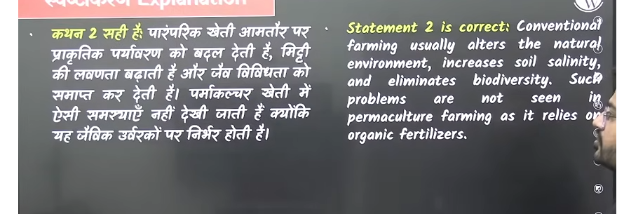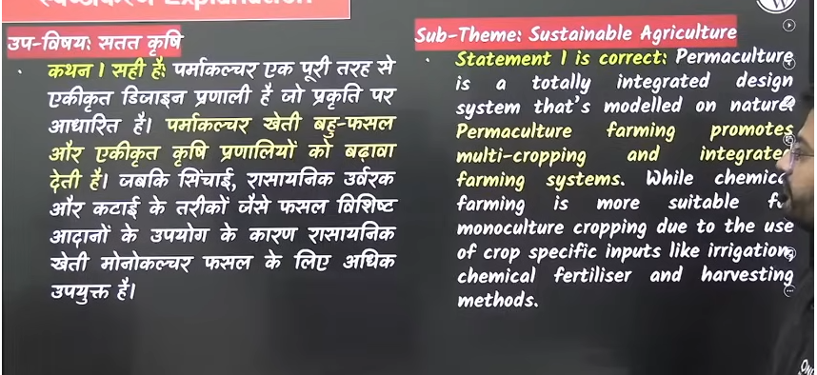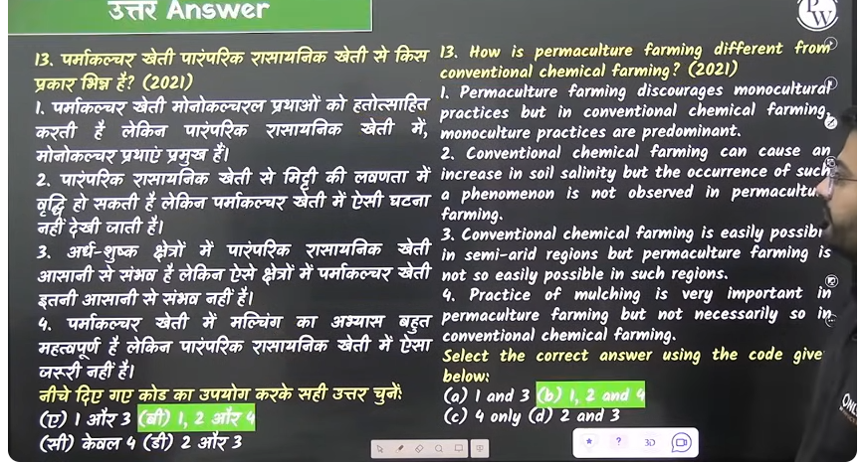

Q29

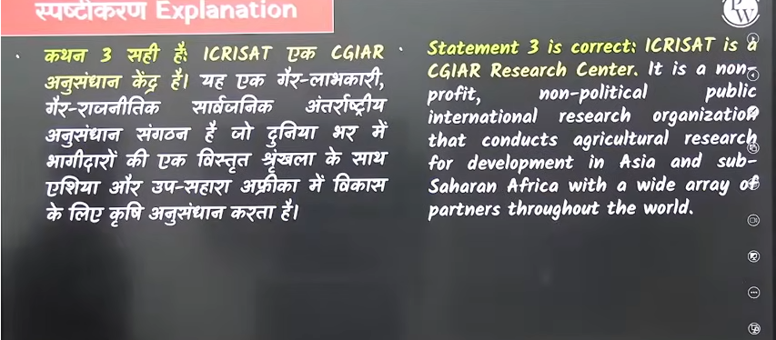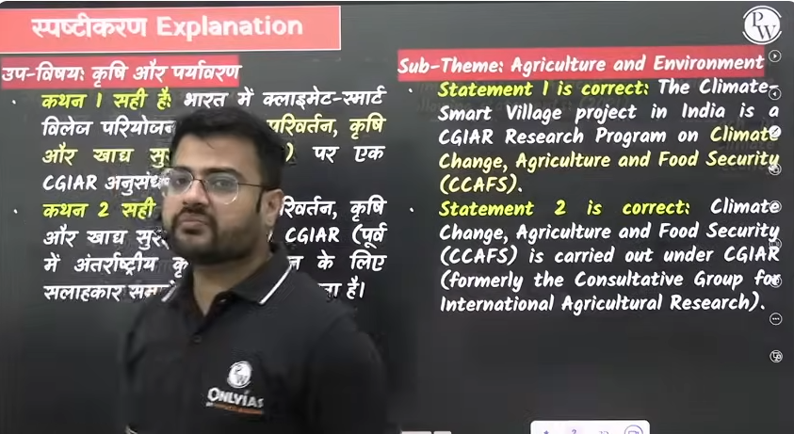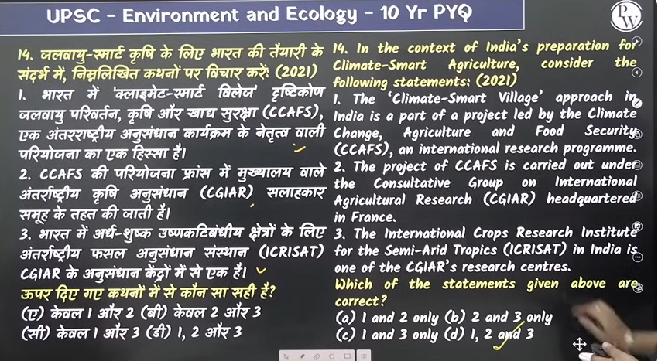

30 1 are correct and 2 are incorrect

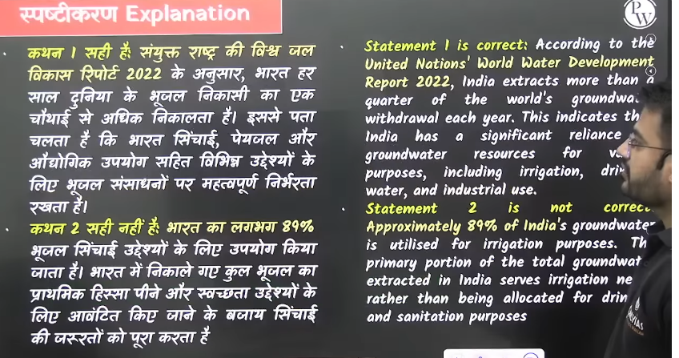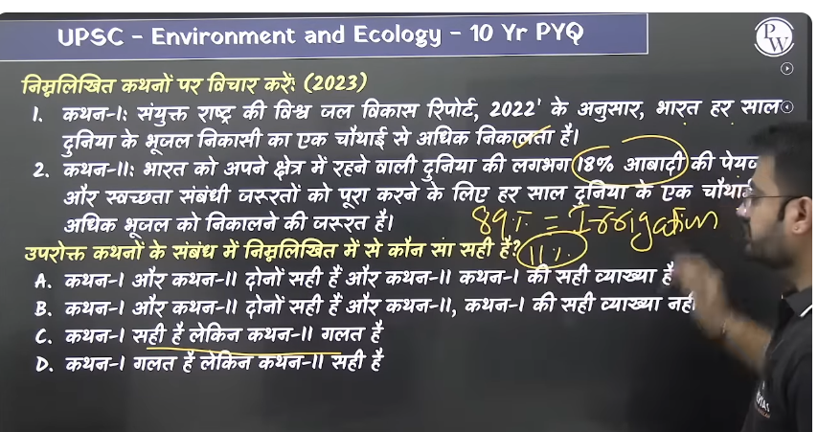

Q. 31

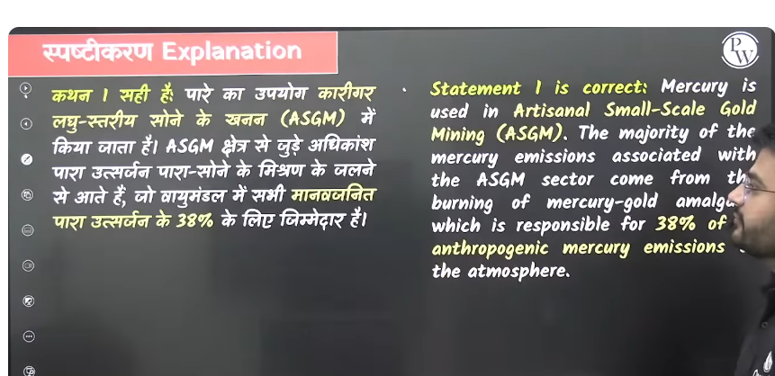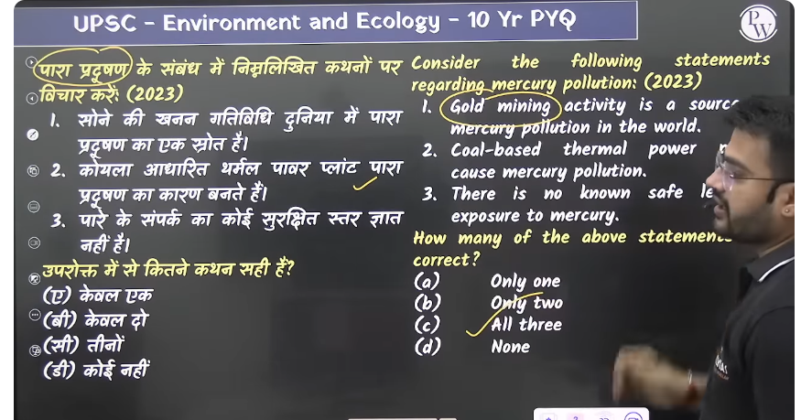

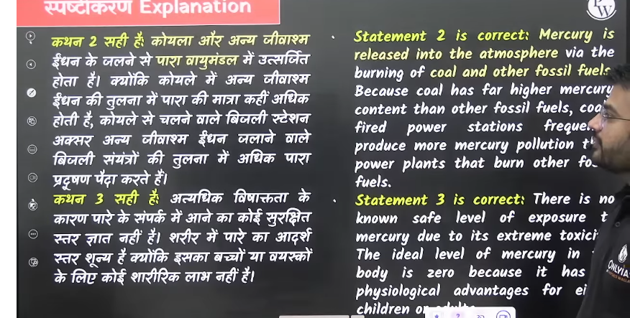

**Q. 32** HFC hydroflorocarban – super pollutant hai 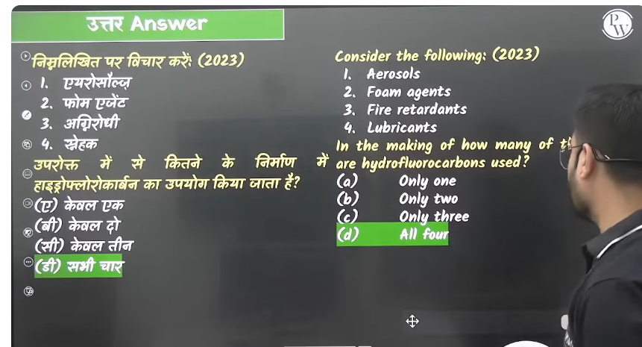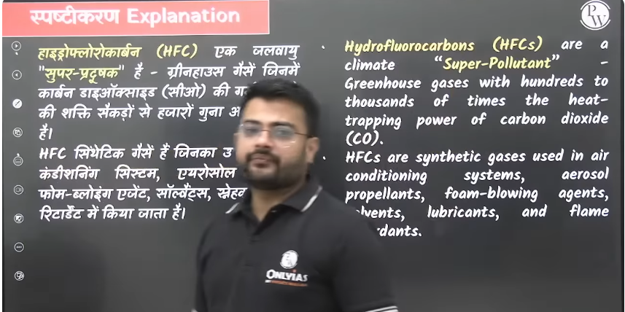

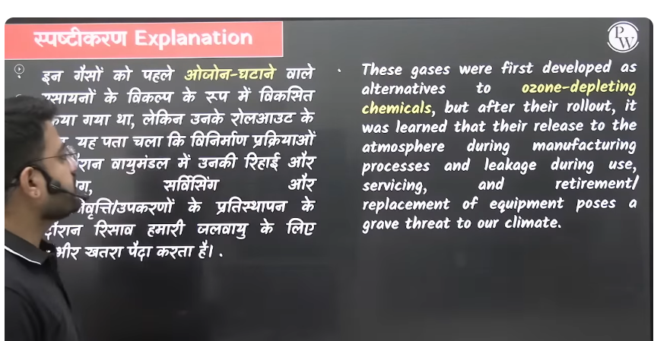

Q.33

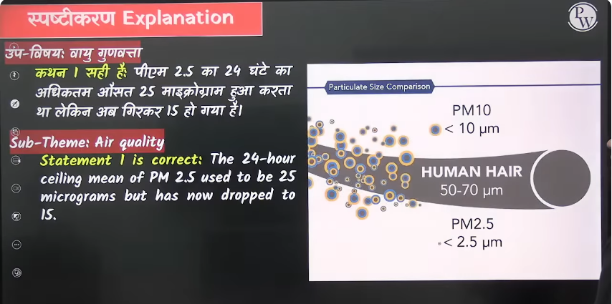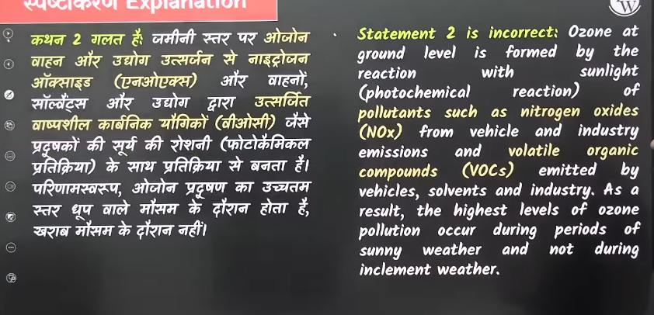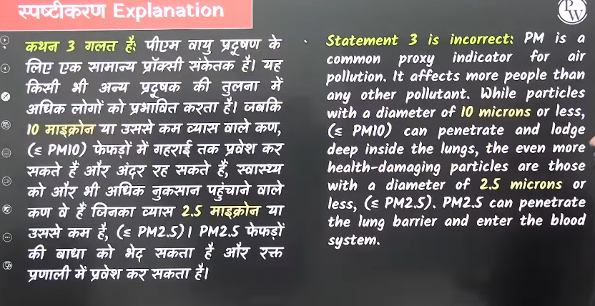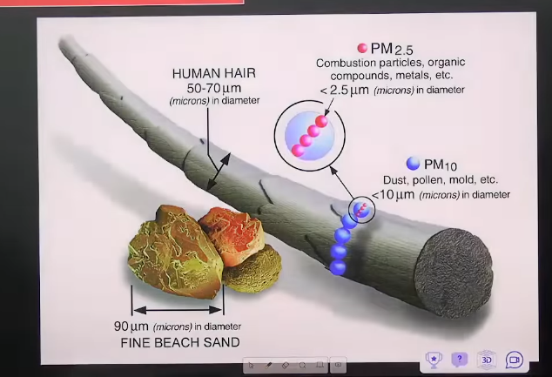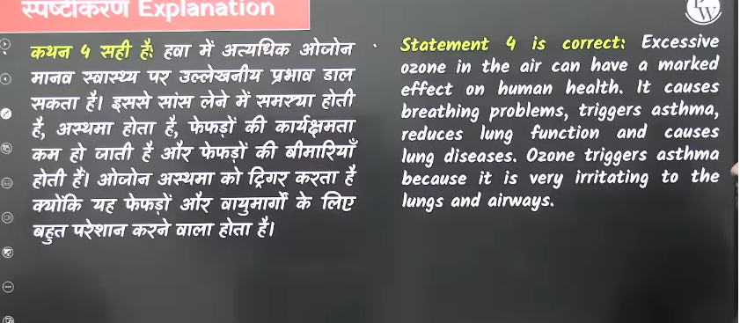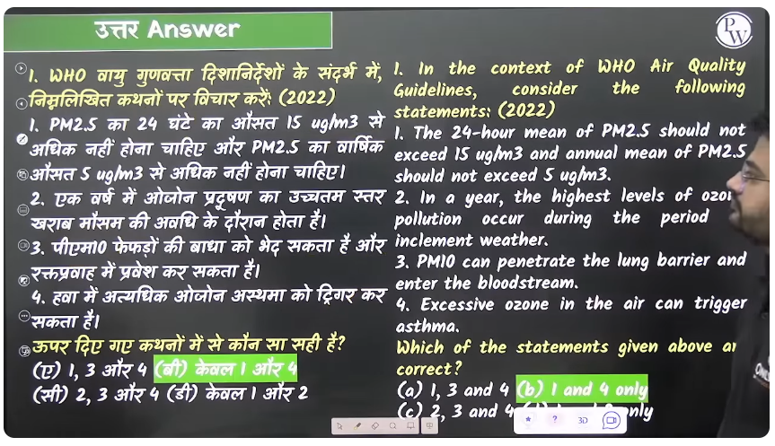

Q. 34

